Code Test SQL

DDL:

create database VirtualArtGallery;

use VirtualArtGallery;

CREATE TABLE Artists (

ArtistID INT PRIMARY KEY,

Name VARCHAR(255) NOT NULL,

Biography TEXT,

Nationality VARCHAR(100));

CREATE TABLE Categories (

CategoryID INT PRIMARY KEY,

Name VARCHAR(100) NOT NULL);

CREATE TABLE Artworks (

ArtworkID INT PRIMARY KEY,

Title VARCHAR(255) NOT NULL,

ArtistID INT,

CategoryID INT,

Year INT,

Description TEXT,

ImageURL VARCHAR(255),

FOREIGN KEY (ArtistID) REFERENCES Artists (ArtistID),

FOREIGN KEY (CategoryID) REFERENCES Categories (CategoryID));

CREATE TABLE Exhibitions (

ExhibitionID INT PRIMARY KEY,

Title VARCHAR(255) NOT NULL,

StartDate DATE,

EndDate DATE,

Description TEXT);

CREATE TABLE ExhibitionArtworks (

ExhibitionID INT,

ArtworkID INT,

PRIMARY KEY (ExhibitionID, ArtworkID),

FOREIGN KEY (ExhibitionID) REFERENCES Exhibitions (ExhibitionID),

FOREIGN KEY (ArtworkID) REFERENCES Artworks (ArtworkID));

DML:

INSERT INTO Artists (ArtistID, Name, Biography, Nationality) VALUES

(1, 'Pablo Picasso', 'Renowned Spanish painter and sculptor.', 'Spanish'),

(2, 'Vincent van Gogh', 'Dutch post-impressionist painter.', 'Dutch'),

(3, 'Leonardo da Vinci', 'Italian polymath of the Renaissance.', 'Italian');

INSERT INTO Categories (CategoryID, Name) VALUES

(1, 'Painting'),

(2, 'Sculpture'),

(3, 'Photography');

INSERT INTO Artworks (ArtworkID, Title, ArtistID, CategoryID, Year, Description, ImageURL) VALUES

(1, 'Starry Night', 2, 1, 1889, 'A famous painting by Vincent van Gogh.', 'starry_night.jpg'),

(2, 'Mona Lisa', 3, 1, 1503, 'The iconic portrait by Leonardo da Vinci.', 'mona_lisa.jpg'),

(3, 'Guernica', 1, 1, 1937, 'Pablo Picasso\'s powerful anti-war mural.', 'guernica.jpg');

INSERT INTO Exhibitions (ExhibitionID, Title, StartDate, EndDate, Description) VALUES

(1, 'Modern Art Masterpieces', '2023-01-01', '2023-03-01', 'A collection of modern art masterpieces.'),

(2, 'Renaissance Art', '2023-04-01', '2023-06-01', 'A showcase of Renaissance art treasures.');

INSERT INTO ExhibitionArtworks (ExhibitionID, ArtworkID) VALUES

(1, 1),

(1, 2),

(1, 3),

(2, 2);

**Question 1**: Retrieve the names of all artists along with the number of artworks they have in the gallery, and list them in descending order of the number of artworks.

Query:

select artists.name, count(artworks.artistid) as NUM

from artworks

join artists on artworks.artistid=artists.artistid

group by artists.artistid

order by NUM desc;

Output:

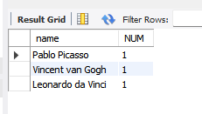

**Question 2:** List the titles of artworks created by artists from 'Spanish' and 'Dutch' nationalities, and order them by the year in ascending order.

Query: select title

from artworks

join artists

on artworks.artistid=artists.artistid

where artists.Nationality="Spanish" or artists.Nationality="Dutch"

order by artworks.year;

Output:

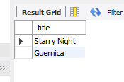

**Question 3:** Find the names of all artists who have artworks in the 'Painting' category, and the number of artworks they have in this category

Query: select artists.name, count(artworks.artistid)

from artworks

join artists

on artworks.artistid=artists.artistid

join Categories

on artworks.CategoryID=Categories.CategoryID

where Categories.name="Painting"

group by artists.name;

Output:

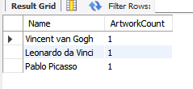

**Question 4:** List the names of artworks from the 'Modern Art Masterpieces' exhibition, along with their artists and categories.

Query: select artworks.title,artists.name,Categories.name

from exhibitionartworks

join artworks

on exhibitionartworks.artworkid = artworks.artworkid

join artists

on artworks.artistid = artists.artistid

join categories

on artworks.categoryid = categories.categoryid

join exhibitions

on exhibitionArtworks.exhibitionid = exhibitions.Exhibitionid

WHERE exhibitions.title = 'Modern Art Masterpieces';

Output:

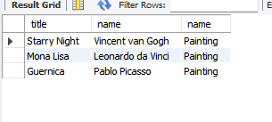

**Question 5:** Find the artists who have more than two artworks in the gallery.

Query: select artists.name, count(artworks.artistid)

from artworks

join artists

on artworks.artistid=artists.artistid

group by artists.artistid

having count(artworks.artistid)>1;

Output:(since every artist has only one art)

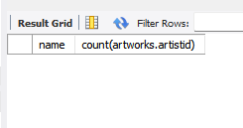

**Question 6:** Find the titles of artworks that were exhibited in both 'Modern Art Masterpieces' and 'Renaissance Art' exhibitions

Query: select artworks.title

from artworks

join exhibitionartworks ea1 on artworks.artworkid = ea1.artworkid

join exhibitions e1 on ea1.exhibitionid = e1.exhibitionid

join exhibitionartworks ea2 on artworks.artworkid = ea2.artworkid

join exhibitions e2 on ea2.exhibitionid = e2.exhibitionid

where e1.title = 'modern art masterpieces' and e2.title = 'renaissance art';

Output:



**Question 7:** Find the total number of artworks in each category

Query: select categories.name, count(artworks.artworkid)

from artworks

join categories on artworks.categoryid = categories.categoryid

group by categories.name;

Output:

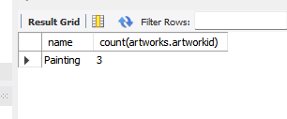

**Queston 8:** List artists who have more than 3 artworks in the gallery.

Query: select artists.name, count(artworks.artistid)

from artworks

join artists

on artworks.artistid=artists.artistid

group by artists.artistid

having count(artworks.artistid)>3;

Output:

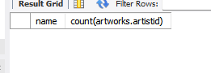

**Question 9:** Find the artworks created by artists from a specific nationality (e.g., Spanish).

Query: select title

from artworks

join artists

on artworks.artistid=artists.artistid

where artists.Nationality="Spanish";

Output:

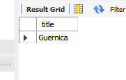

**Question 10:** List exhibitions that feature artwork by both Vincent van Gogh and Leonardo da Vinci.

Query: select exhibitions.title

from exhibitions

join exhibitionartworks ea1 on exhibitions.exhibitionid = ea1.exhibitionid

join artworks a1 on ea1.artworkid = a1.artworkid

join exhibitionartworks ea2 on exhibitions.exhibitionid = ea2.exhibitionid

join artworks a2 on ea2.artworkid = a2.artworkid

join artists art1 on a1.artistid = art1.artistid

join artists art2 on a2.artistid = art2.artistid

where art1.name = 'Vincent Van Gogh' and art2.name = 'Leonardo Da Vinci';

Output:

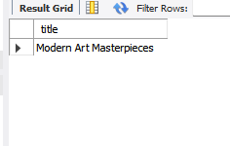

**Question 11:** Find all the artworks that have not been included in any exhibition.

Query:

select artworks.Title

from artworks

where Artworks.artworkid not in (

select artworkid

from ExhibitionArtworks);

Output:



**Question 12:** List artists who have created artworks in all available categories.

Query: select artists.name

from artworks

join categories on artworks.categoryid=categories.categoryid

join artists on artworks.artistid=artists.artistid

where count(Artworks.artistid)=count(categories.name);

Output: Error

**Question 13**: List the total number of artworks in each category.

Query: select categories.name, count(artworks.artworkid)

from artworks

join categories on artworks.categoryid = categories.categoryid

group by categories.name;

Output:

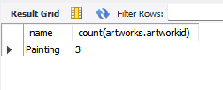

**Question 14:** Find the artists who have more than 2 artworks in the gallery.

Query: select artists.name, count(artworks.artistid)

from artworks

join artists

on artworks.artistid=artists.artistid

group by artists.artistid

having count(artworks.artistid)>2;

Output: (all artist have only one artwork)

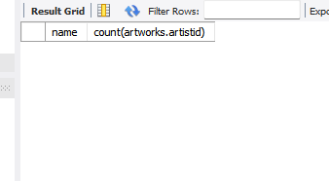

**Question 15**: List the categories with the average year of artworks they contain, only for categories with more than 1 artwork.

Query: select categories.name, avg(artworks.year)

from categories

join artworks on categories.categoryid=artworks.categoryid

group by categories.categoryid

having count(artworks.artworkid)>1;

Output:

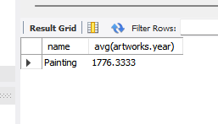

**Question 16:** Find the artworks that were exhibited in the 'Modern Art Masterpieces' exhibition.

Query: select artworks.title

from artworks

join exhibitionartworks on artworks.artworkid = exhibitionartworks.artworkid

join exhibitions on exhibitionartworks.exhibitionid = exhibitions.exhibitionid

where exhibitions.title = 'modern art masterpieces';

Output:

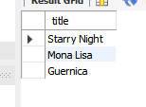

**Question 17**: Find the categories where the average year of artworks is greater than the average year of all artworks.

**Question 18:** List the artworks that were not exhibited in any exhibition.

Query: select title

from artworks

where artworkid not in (

select artworkid

from exhibitionartworks

);

Output:



**Question 19**: Show artists who have artworks in the same category as "Mona Lisa."

Query: select distinct artists.name

from artists

join artworks on artists.artistid = artworks.artistid

where artworks.categoryid = (

select categoryid

from artworks

where title = 'mona lisa'

);

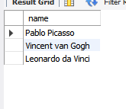

**Question 20:** List the names of artists and the number of artworks they have in the gallery.

Query: select artists.name, count(artworks.artistid)

from artworks

join artists on artworks.artistid=artists.artistid

group by artists.name;

Output:

